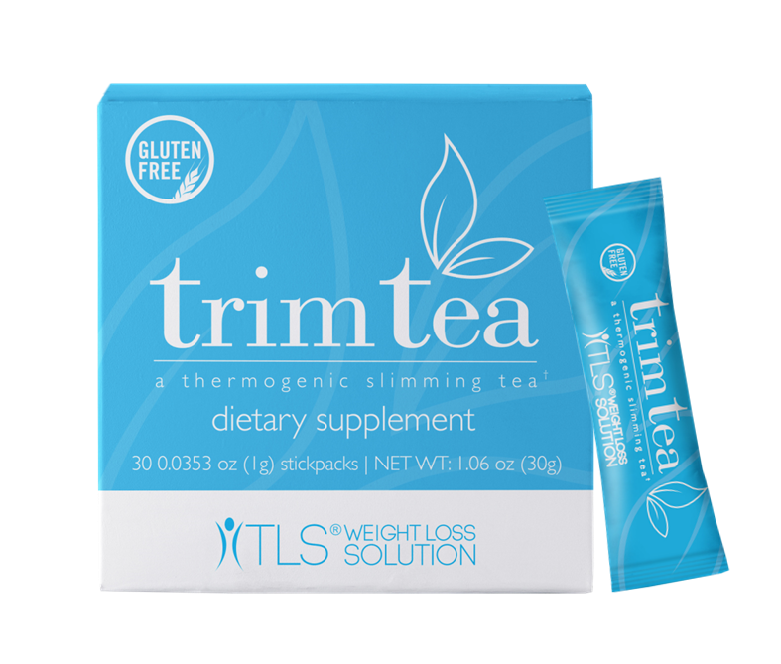

**WHAT IS TRIM TEA**

This gluten-free, thermogenic slimming tea is formulated with WellTrim® iG and black tea extract to promote an effective, multifunctional method to weight loss. Trim Tea uses a three-pronged approach to tackle weight management: targeting satiety, appetite control and metabolic balance.

**In a double-blind placebo 10-week controlled study on WellTrim ® iG,**

**52 participants lost an average of**

**28 pounds and 6.3% body fat**

**In other clinical studies, WellTrim® iG, resulted in •**

* **51.7% reduction in C-Reactive Protein Levels •**
* **22.5% reduction in blood glucose levels •**
* **80.9% reduction in fat production •**
* **26.3% reduction in total Cholesterol •**
* **27.2% reduction in LDL Cholesterol**

While there are other weight management competitors on the market that use WellTrim® iG, most of them do not offer a product in the form of a tea.

WellTrim® iG, is a natural, clinically tested seed extract for weight loss and metabolic wellness. It has also shown in research studies to promote feelings of fullness.

Black tea extract enhances TLS Trim Tea as it contains antioxidants that have been shown to provide cardiovascular health support.

Most slimming teas on the market are sold as 14-day supplies and require two daily servings.

**TLS Trim Tea is a powerful formula that only recommends a single daily serving, and unlike some slimming teas does not induce a laxative effect, which is a quick fix rather than a sustainable solution for long-term weight management.**

TLS Trim Tea can be enjoyed hot or cold and is packaged in easy-to-use stick packs, which makes it easy to take with you when you’re on the go!

NOTE: **3 BOXES OF TRIM TEA ARE NEEDED FOR RESULTS IN THE 10-WEEK STUDY - $39.95 per box – 30 packets per box = $1.33 per cup**

**HOW TO TAKE:**

* Mix with 1 Trim tea packet in 6 oz. of cool or hot water once a day
* Best when taken as is NO added sweeteners or dairy for results in studies

Take 30 to 60 min. before a meal for appetite control

**Contact: Valerie Martin 860-982-2950**



